La Petite Trotte a Leon – aka eating your way around Mont Blanc!
It had all seemed such a good idea in January, a change from the UTMB which I had completed for the last three years, some good company who could all speak English and a bit of a challenge on an interesting route in the Alps. La Petite Trotte is the latest addition in the UTMB series. The route is not marked but does take established paths, the terrain is much steeper and spends longer above 2500m and goes off the beaten track. To check that teams are not cheating, we were given a tracking device that would send text messages back to Chamonix with our latest position, except where there was no ‘phone reception. We also had to take pictures of each other at features on the route, to check that we kept together and did not accidently leave a team member behind! There were no aid stations although we could use the refuges for food, rest and recovery. This was the purists route!
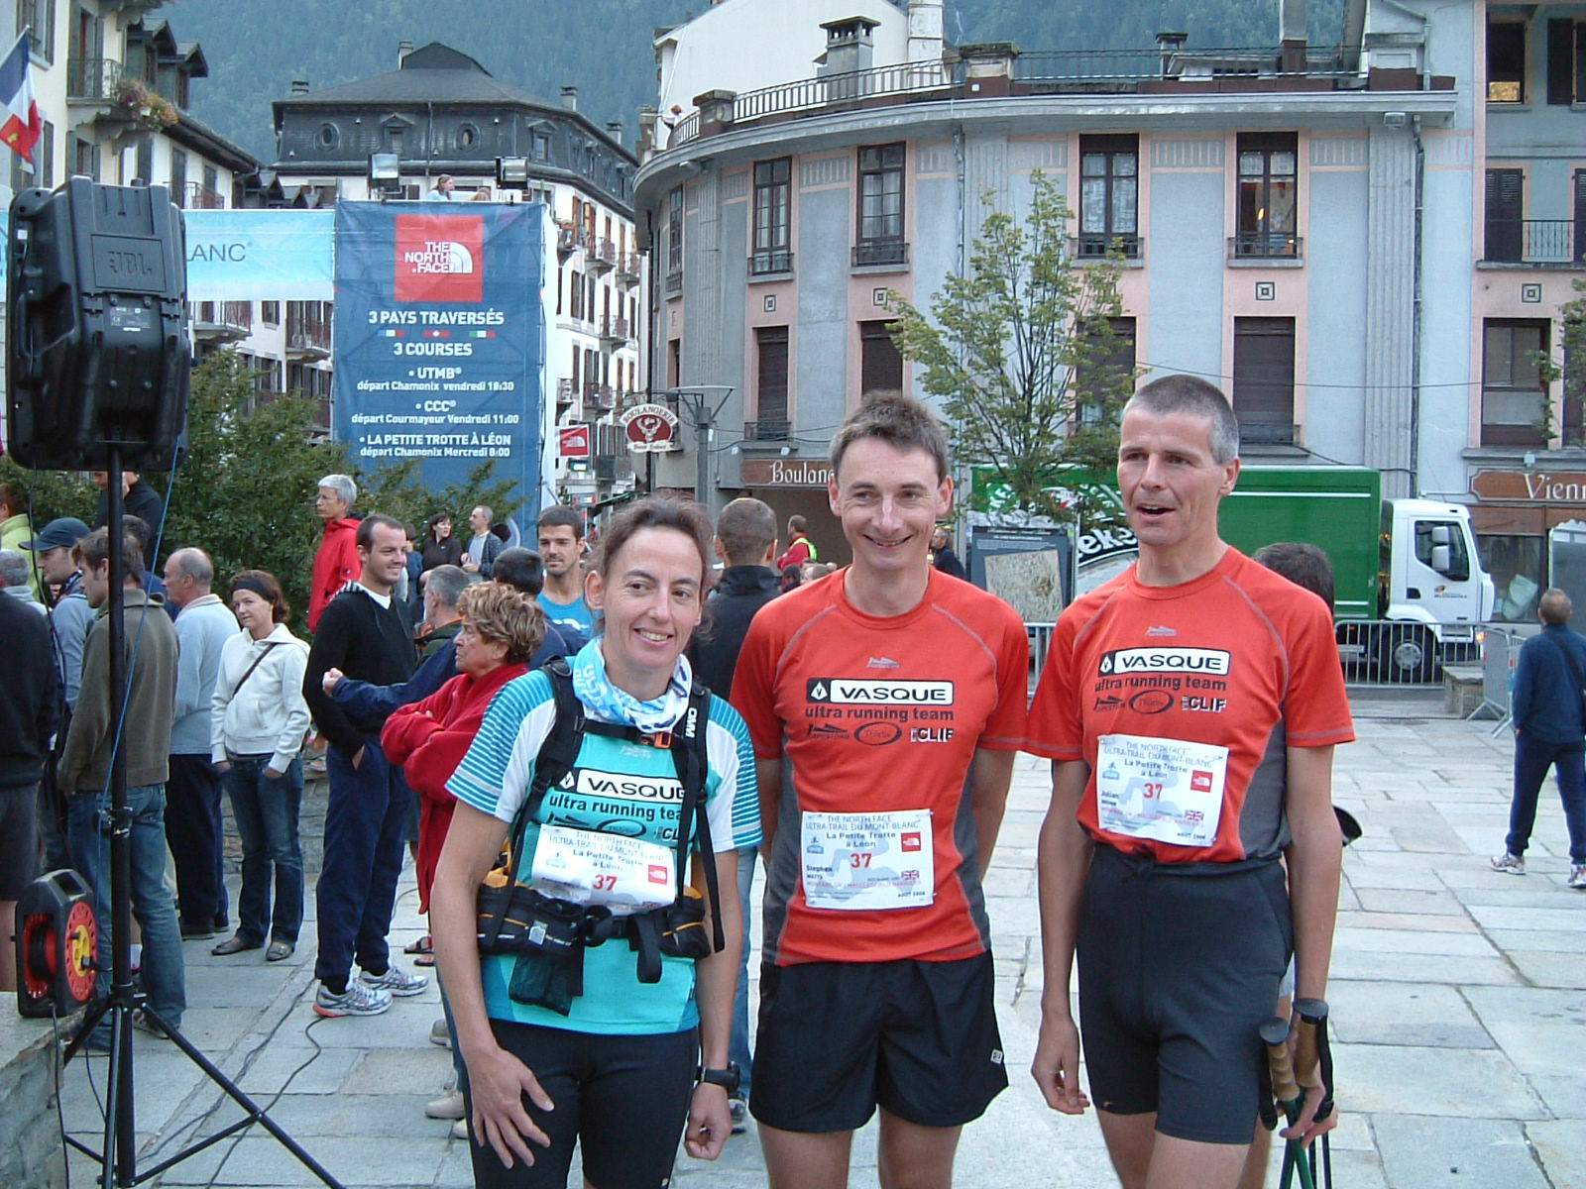
Mandy, Steve and Julian – Team Vasque at the start of La Petite Trotte 2008
At 7:45am on a sunny Wednesday morning in Chamonix, 220km seemed a VERY long way and 17,000m of ascent insurmountable. Added to this challenge, my team-mates Julian and Steve were nowhere to be seen....we were due off in fifteen minutes. Of course they arrived just in time with several minutes to spare! Other teams were readying their GPS’s with their 3000 data points....we got out our map and compass to the amusement of the assembled French and Italian teams.
At 8:00am we were off, making a token effort to jog through the streets of Chamonix until we joined the path up the first 1300m climb to Aiguillette des Houches a great viewpoint over Mont Blanc. No navigation problems so far as there were plenty of people to follow and the sun was shining brightly. It did soon become apparent that water could be a problem. It was still early in the morning and we were already sweating going up the first hill. We reached the first photo stop, still smiling I think, and then began the long descent down to Servoz. It was good to see that we were not last, but there was a long way to go. More photos and water in the village square and then along the river and up 1100m to Le Prarion from the opposite direction to the main race route where it was good to stop for more water in the refuge....although the terrace and a beer would have been even better. Steve was caught on film and asked when we were going to start running....”have you tried running up those hills”? The climbs were relentless and we had only been going for about 5 hours. It was great to see friends and family at Col de Voza where we managed a trot for the cameras. It was up again, to Col de Tricot across the wobbly suspension bridge and then after a few more ups and downs we reached the first partner refuge Chalets du Truc. We were now definitely feeling peckish as it was late afternoon and it was with great disappointment we realised that the soup and pasta was not going to fuel us for too long. Julian who is far more experienced in this long distance stuff was firmly of the opinion that we needed to eat our way around and he was right, but we were not going to start that here.
The next refuge was better and we stopped for a proper meal, well it was dinner time by then and we were treated ourselves to soup and proper pasta. The heat was now going out of the day and our emerging plan was to push on to Croix de la Bonhomme and have a long stop there, after all we had all done that bit in the dark before and it was only another 1000m of climbing. Revitalised we made good progress and managed without torches until we were past la Balme. It was surprisingly, a lot more difficult finding and keeping to the path without the aid of the UTMB markers. We stopped at the refuge and refuelled again with several bowls of soup and pasta. Then we decided to try and rest for a couple of hours. We were beginning to realise that navigating your way around in the dark was a lot trickier than following the crowds and the terrain was a lot rougher and more remote. After a couple of hours of not being asleep, we got up and set forth towards Col des Fours by torchlight. Although the night was clear we did lose right path and spent a few minutes getting back on route. Then a long descent to Ville de Glaciers which we reached at about 3:00am followed by the long pull up to Col de La Seigne where there was a big cabin full of water....but sadly firmly locked. We were now in Italy and the well signed paths disappeared, as if by magic. We struggled to find our way across ankle turning slopes, following cairns that seemed to disappear into thin air. We at last reached Col des Chavannes as the day was dawning. This was the ground that we had been advised not to traverse in the dark, and although the paths were clear to follow, the drops a few metres away were massive. Prudent advice we figured. We were traversing pastures high above Refuge Elisabetta with some knife edge cols and stunning views in the early morning light. The final two cols were sharp and edgy and then it was a steep descent down towards the main race route and Col Checrouit....where there would be breakfast and a big cup of cafe au lait....I hoped. We had not seen anyone since leaving the Refuge but the guardian at Maison Vieulle made us very welcome. We had as much breakfast as we could eat for 5 Euros, naturally Julian could manage a lot more than me! Although it was about 9:00am before we left, we were already planning lunch at Refuge Bertone. If we were going to eat our way around then we were would need some sustenance to get us to Col du Grand Saint Bernard which was day’s hike away. We got a few extra rations at the supermarket in La Saxe and then onwards and upwards to Refuge Bertone in the beautiful midday sun. This route was no easier than the approach from Courmayeur but there were loads of day trippers on the route. Lunch was served....yes it was soup and pasta with the extra treat of a piece of cake. We met the Belgian team at the refuge and I just had the feeling that they were definitely out to beat us. Although we had to remember that this was only a challenge and not in the least competitive! They were very cagey about their plans, so were we, but that’s because we did not really have any.
It was from Bertone that we did get to follow some of the race markers and hats off to the CCC runners as the climb up Col Sapin is a big one. In the distance we could see the cols that we were aiming for and although only 6km away they looked big and gnarly. Col Malatra was steep and I was glad we were tackling it in the afternoon sunshine, as negotiating the wires and metal steps would have been more of a challenge in the dark. We treated ourselves to a delicious piece of cold pizza and a peach at the bottom and then we were off up the last climb before the half way point. We managed to overhaul a team on the climb, the first people we had seen for several hours. On the descent, the map and paths failed to agree, so that it seemed an interminable plod to the road and the Hospice Grand Saint Bernard, made worse when the roadworks in Italy had destroyed the path on the final kilometre.
It was about 8:00pm on our second night, in a bitter wind when we eventually rolled into the Hospice, where we were warmly welcomed and filmed again. We were surprised that we were the fifth team to arrive, surely many would not make it there that night. The showers were divine, but the soup and pasta were rubbish! The instructions had been taken literally, there was only pasta, no olive oil, herbs or sauce. We were reluctantly given some butter and that made it palatable. We had decided to have a proper sleep here. After some blister popping with the aid of my race number safety pin, carefully sterilised with an antiseptic wipe, I went to bed exhausted, somehow found it impossible to sleep in a stuffy dortoir, full of snoring men? The alarm went at 4:00am and after a frugal breakfast we hit the trail at 5:00am on our third morning. We figured correctly that that the paths would be well signed in Switzerland and we would have little problem route finding for a few hours in the dark. The climbs were smaller than yesterday, but the paths were steep and we stayed high, well over 2500m with some tricky scrambly sections. A few teams had set off about an hour after us and to our dismay overtook us by missing out one of the descents to the Lacs de Fenetre. We were furious, but energised! Two nights without having had any proper sleep was beginning to tell. My nose started to bleed and clutching a tissue to my nose, I could not keep up with the others over the rocky, stony boulders. Then disaster almost struck as I tripped and took a rolling tumble on the rocks. Fortunately only a few cuts and bruises, but it shook me up badly for a few minutes as the blood drained from my head. Whilst we did not pack all the gear recommended in the medical kit, a few antiseptic wipes and plasters were very useful! I was still feeling wobbly as we made the long gentle descent down towards Refuge La Tsissette, where we had a bowl of organic home grown vegetable soup probably as an aperitif to lunch.
It was now a climb up under a ski slope and then down to an alpage where the cows were ringing their bells. Now a long descent to Praz de Fort and could my knees feel it now. After long cool drink from the water source we found the Sentier de Champignons which was to lead us to Champex. The map and the trail did not seem to bear any resemblance to each other. Steve was VERY unhappy with the map, but after a brief abortive foray into the woods we made it through to Champex where we had been promising ourselves some of Leon’s famous tarte aux myrtilles to fortify ourselves before tackling the Fenetre d’Arpette, (which is the gnarly alternative to Bovine). But alas when we made our way to the UTMB aid station the tarte aux myrtilles had not yet arrived. So we made do with some biscuits and water and made our way past Leon’s famous boulangerie where we stopped for a photocall with the man himself. He certainly has a lot to answer for! Then along to the youth hostel to check in. Hooray..more soup and pasta..but with a choice of sauce and chocolate mousse for pudding. As usual Steve and Julian managed seconds and the then the Italians arrived. They ordered a round of beers!
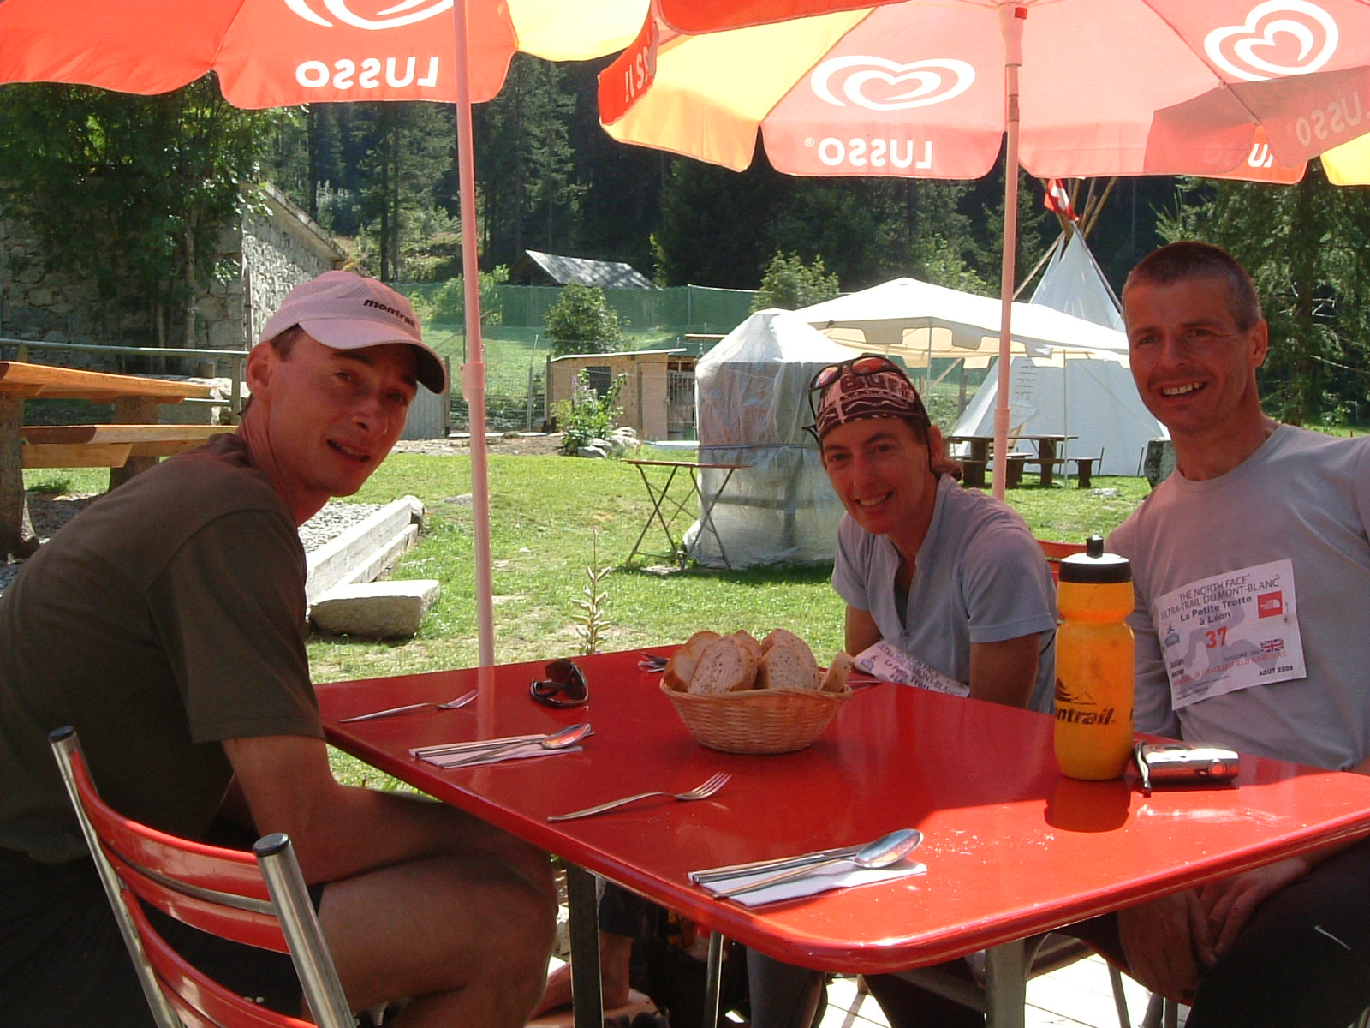
Team Vasque in Champex awaiting another meal of soup and pasta!
Well fortified, it was now mid afternoon as we tackled the last climb of the day up to Fenetre d’Arpette. It was a long slog, but as usual we got into a rhythm and quickly saw it off. It was now 6:30pm on Friday.We sat at the top mischievously debating giving Martin and Mark a call as they sat on the start line for the main race just to make them extra nervous! The long rocky descent to Col de la Forclaz was interminable for Julian and me and it was still a long way on the flat alongside the bisses which are the old irrigation channels that were used to bring water from the glacier. Having not seen anyone since Champex, we could hear the party already in full swing in Trient far below us and we cheered on the front runners in the CCC. It was just getting dark on night three as we approached the hotel at Col del La Forclaz as the marshals tried to direct us onto the CCC route! We sat down in the barn for the usual fare and then as it was now dark we decided to try to steal an hour’s sleep. A vain hope with the incessant ringing of cowbells by CCC supporters and the speeding traffic rumbling outside the tent. At 10:30pm we gave up and had some tarte aux myrtilles and then headed out into the dark night up the next big climb. This was going to be our final push to Chamonix, we did not want another night on the trail. Mont d’Arpille offered us a lofty view over the night lights of Martigny to the North and looking back a huge line of headlights from the CCC runners coming off Bovine. The next 6 hours were all on remote and not so well used paths and route finding was far from easy, especially as we were all so, so tired. One time we heard a team behind us shouting to find their “lost” member, that did spur us on briefly. I think they must have found him eventually, but who knows. We stopped in the small village of Le Tretien sitting on a bench to eat our butties in the dead of night. Luckily nobody passed by or we may have looked like escapees from the local asylum! The next bit was the hardest, onwards through interminable forest, I did think that I was going to go to sleep on my feet and my brain could not cope with the task of putting one foot in front of the other. Surely walking cannot be this hard?
We remembered to take our team photo at some indistinct place called Fenestral and plodded on willing for a glimpse of the Emosson dam. When we were approaching civilisation, which we figured must the barrage, none of our brains could work out that we were looking on to the car-park that serves the barrage. In fact we were so worried that Julian may need some sustenance and we offered him a gel, which he accepted. It perked him up, as he was quick to riposte that “yes that was the worst thing that he had ever tasted”. However the sun was coming up and it had the usual re-vitalising effect on our exhausted brains and bodies...they started to work again! The sun rise was beautiful as we looked back into Switzerland. Looking the other way in the distance, we could see the refuge, which meant breakfast. But first we had the barrage to negotiate as well as the traces of dinosaurs to seek out and worst of all a 200m scramble before we could be welcomed inside. The Belgians and the French teams were just leaving as we arrived, but we took our time over breakfast mainly because we were so tired, The coffee and chocolate were good and we headed out for the penultimate climb. The climb was fine, but the descent was a rocky, loose scree slope. The Italians in front negotiated this much better than me so we dropped behind again. Then the last refuge where we spent too long having coffee and cake, but at least the end was in sight (well sort of) and I had been greeted with a welcome of “La premiere dame”, we just had to keep it that way and try to be the first mixed team home.
We got down to le Buet and joined the road to Col des Montets and knew we had this in the bag. The UTMB’ers may have feared the last climb up to La Flegere but it was on a big marked path and was only 700m! It was mid afternoon by now and the sun was hot and there were crowds of people everywhere! We met loads of friends on the way to La Flegere. On the descent even the helicopter came out to visit us, well maybe he was watching out for the UTMB winner who overtook us! We jogged all the way down into Chamonix and were welcomed by the crowds, (a new experience for me as I have always finished this race between 5 and 6am). Then just before 4:00pm, across the finish line and big hugs, tears and kisses all around! Steve and Julian were brilliant team-mates and although difficult to say we enjoyed this epic or that we would rush to do it again, we never doubted that we would get around together, it was just a question of how long it would take. Does that make us all as mad as each other, especially as this was not even a race!!

Post Script – We were eventually classified as the 5th complete team to finish and the first mixed team and first and only British team to finish. Of 61 teams who started, only 29 finished. This was really quite an epic challenge and the statistics would have been worse if the weather had turned bad. Looking at the stats we took 79 hours 55 minutes....only 55 minutes from third place (but of course it wasn’t a race!) The winning team took 65 hours 45minutes, that was truly an amazing achievement.
Post Post Script – My hand had swollen up considerably by the end and was painful to bend and straighten, which was of concern as I needed to use it rowing the following week at the World Masters Regatta in Lithuania. Happily it functioned OK in the regatta as did the rest of my weary limbs. We got beaten by some ex-Olympic Estonian women in our Eights race, but revenge was sweet in our coxless four when we beat them by 0.2second. Well the races are only 1000m so margins are tight! So for two weeks work I am the proud owner of a cowbell from the PTL and a World Masters Rowing medal. Now it’s time for some R&R.

